SYSTEM REQUIRMENT SPECIFICATIONS FOR CLIENT SERVER BASED LIVE MEETING

PURPOSE OF THE SYSTEM
This project is mainly developed for the communication of Employees of organization located at different locations. The project entitled “Live Meeting” set of platform for the project leaders and administrator to send messages to keep constant interaction with the programmers.

In the proposed system is the administrator can sit at his system and communicate with the project leaders, programmers and can also maintain the login time, logout time. He can chat about the project going on with both the programmers and project leaders. This project also maintains offline messages. The administrator sees the IP address of the system of project leader/programmer he is interested and chat with the people .The project leader gives the instant report about the project to the administrator.

Through this Communication System, Whenever user logs-in into the system then login time is recorded in the administrator’s system automatically. This project makes the most of the tedious and mundane deskwork to minimize. This facilitates the user to concentrate more on the project and less on the managing of these tasks.

The proposed system maintains…
- Frequent interaction between the administrator and the project leaders/programmers.
- Automatically recording the login time/logout time of the user.
- Employee Hierarchical

EXISTING SYSTEM:
The existing system is semi-automated or manual system. It needs to be converted into automated system. In the existing system organization people are using public domains like yahoo mail or Gmail etc but it has lot of risk of mismanagement of data and less Security. No proper coordination between different Applications and Users in the organization.
Anonymous user can be allowed like these public domains. It is critical to share their information like this environment. Some organizations are using manual system. In the manual system the data can be stored and transferred in the form of disk drives or paper.
Semi automated systems are connected through LAN but they are using data in local systems like Ms-Access or MS-Excel etc. In local data base there is no Option for data security and data integrity.

PROPOSED SYSTEM

The proposed system is having frequent interaction between administrator and the project members by using email and chat modules.
The development of the new system contains the following activities, which try to automate the entire process keeping in view of the database integration approach. User friendliness is provided in the application with various controls. The system makes the overall project management much easier and flexible. There is no risk of data mismanagement at any level while the project development is under process. It provides high level of security with different level of authentication. Users from any part of the world can make use of the system. New system will process accurate results. New system will be much better in performance as compared to existing one.

STUDY OF THE SYSTEM
The Live Meeting Project is mainly based on online chat features with other features like (Member registration feature/ Sending and Receiving mails feature/ Integrated Security feature etc.).
Developing a chat application:
There are different ways to implement a chat application.
In ASP.Net, there are two ways in which we can develop a chat application.
HTML Chat
First one is the HTML chat, where in the chat application is developed using web forms and based on the request response model i.e. the client will keep pinging to the server to check any messages are there for that person, and if we have to send any message, simply post it to the server. In this case the page which provides the chat web form have to be refreshed every time (which is configurable), and will not be a good experience for the user. But regarding the security perspective, this method will be the most matching.
Windows Chat
The second asp.net chat option is to create an Activex control, and plug in to the page so that it implements any of the chat protocols in sync with the chat server .Here we have to create a chat server as some windows service, using Sockets. So that the Activex and the chat server can talk with each of them through some predefined chat protocol or user can define his own custom chat protocol. This will provide better chatting facilities and the web page in which the chat client resides need not be refreshed. Here since we are using Activex, some sort of security problems may arise.
These are the two methods, where in we can develop chat application in .net. The Activex control in the second method can be modified to develop a windows application i.e. a chat Messenger sort of application.

Number of Modules
The system after careful analysis has been identified to be presented with the following modules:

The modules involved are:
- Online Chat Module
- Member registration Module
- Sending and Receiving mails.
- Integrated Security Module
- Admin Module.

Online Chat Module:
- Registered members are allowed to chat with other registered members. Member needs to be authenticated before entering to chat window. Chatting feature is available
(Single Mode) where 1 member can chat with another member.
Member registration Module:
- Member can register and sign in here. For registration, member has to provide personal details, address details, employment details, account details and they have to agree with policies.
- Member can sign in by providing their account details (Username and password).

Sending and Receiving mails:
- By making use of this module, Members can send/receive/view mails. Many features have been provided to members so that they can 1) manage (view/ edit/ delete) their mails, 2) forward mails, 3) send attachments, 4) send group mail, manage mails in folders etc.
Integrated Security Module:
- This module is made is provide security features to the application.
Admin Module:
- Admin is a super user and hence responsible for a) Site Maintenance, b) Members Management, c) Mails management and d) Generate various reports.

INPUTS & OUTPUTS
The main inputs, outputs and major functions of the system are as follows.
Inputs:
Member Registration details:
Registration module is responsible for member registration and login. While registration, member will be prompted for his 1) login account details (username, password, hint question, answer), 2) his personal details, 3) his contact address, 4) his company profile etc. At time of sign in, Member has to provide username and password. In Message compose box, Member has to provide Message to send with Email-ID (to whom message has to be sent.). In the chat window, Member has to provide messages.

Outputs:
- On successful registration, member will be provided confirmation mail.
- On successful signing in, member will be placed to My Account page.
- In Chat window, Member will be getting messages sent by other members.

SCOPE OF THE PROJECT

This Document plays a vital role in the development life cycle (SDLC) as it describes the complete requirement of the system. It is meant for use by the developers and will be the basic during testing phase. Any changes made to the requirements in the future will have to go through formal change approval process.

WATER FALL MODEL was being chosen because all requirements were known beforehand and the objective of our software development is the computerization/automation of an already existing manual working system.
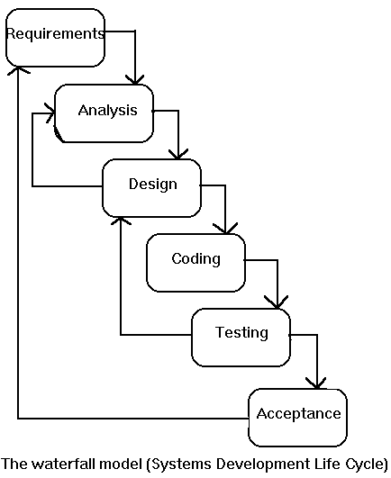

The developer is responsible for:
- Developing the system, which meets the SRS and solving all the requirements of the system?
- Demonstrating the system and installing the system at client's location after the acceptance testing is successful.
- Submitting the required user manual describing the system interfaces to work on it and also the documents of the system.
- Conducting any user training that might be needed for using the system.
- Maintaining the system for a period of one year after installation.

INPUT DESIGN

Input design is a part of overall system design. The main objective during the input design is as given below:
- To produce a cost-effective method of input.
- To achive the highest possible level of accuracy.
- To ensure that the input is acceptable and understood by the user.

INPUT STAGES:
The main input stages can be listed as below:
- Data recording
- Data transcription
- Data conversion
- Data verification
- Data control
- Data transmission
- Data validation
- Data correction

INPUT TYPES:
It is necessary to determine the various types of inputs. Inputs can be categorized as follows:
- External inputs, which are prime inputs for the system.
- Internal inputs, which are user communications with the system.
- Operational, which are computer department’s communications to the system?
- Interactive, which are inputs entered during a dialogue.

INPUT MEDIA:
At this stage choice has to be made about the input media. To conclude about the input media consideration has to be given to;
- Type of input
- Flexibility of format
- Speed
- Accuracy
- Verification methods
- Rejection rates
- Ease of correction
- Storage and handling requirements
- Security
- Easy to use
- Portabilility

Keeping in view the above description of the input types and input media, it can be said that most of the inputs are of the form of internal and interactive. As
Input data is to be the directly keyed in by the user, the keyboard can be considered to be the most suitable input device.

OUTPUT DESIGN

Outputs from computer systems are required primarily to communicate the results of processing to users. They are also used to provide a permanent copy of the results for later consultation. The various types of outputs in general are:
- External Outputs, whose destination is outside the organization,
- Internal Outputs whose destination is with in organization and they are the
- User’s main interface with the computer.
- Operational outputs whose use is purely with in the computer department.
- Interface outputs, which involve the user in communicating directly with

OUTPUT DEFINITION
The outputs should be defined in terms of the following points:
- Type of the output
- Content of the output
- Format of the output
- Location of the output
- Frequency of the output
- Volume of the output
- Sequence of the output

It is not always desirable to print or display data as it is held on a computer. It should be decided as which form of the output is the most suitable.

For Example
- Will decimal points need to be inserted
- Should leading zeros be suppressed.

OUTPUT MEDIA:
In the next stage it is to be decided that which medium is the most appropriate for the output. The main considerations when deciding about the output media are:

- The suitability for the device to the particular application.
- The need for a hard copy.
- The response time required.
- The location of the users
- The software and hardware available.

Keeping in view the above description the project is to have outputs mainly coming under the category of internal outputs. The main outputs desired according to the requirement specification are:

The outputs were needed to be generated as a hot copy and as well as queries to be viewed on the screen. Keeping in view these outputs, the format for the output is taken from the outputs, which are currently being obtained after manual processing. The standard printer is to be used as output media for hard copies.

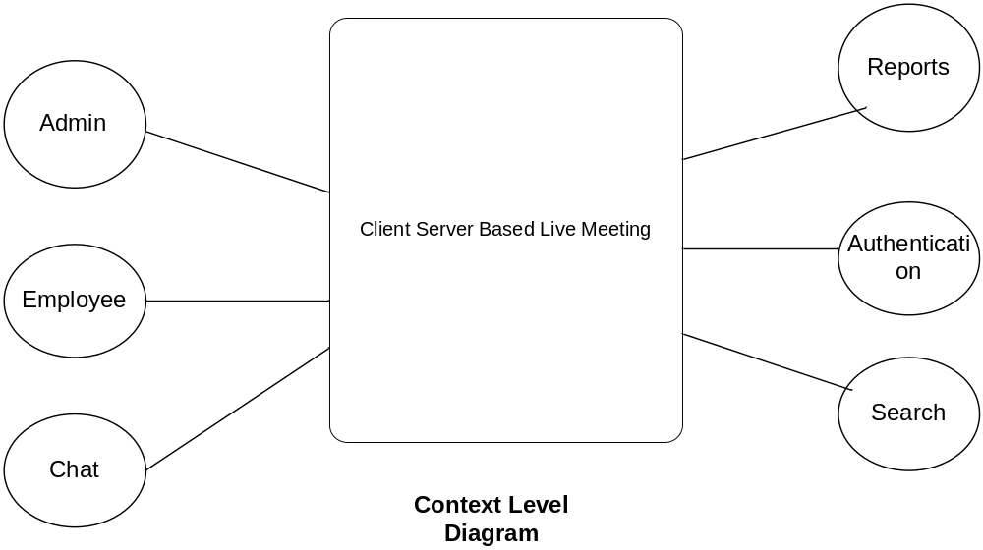
PERFORMANCE REQUIREMENTS:

Performance is measured in terms of the output provided by the application. Requirement specification plays an important part in the analysis of a system. Only when the requirement specifications are properly given, it is possible to design a system, which will fit into required environment. It rests largely in the part of the users of the existing system to give the requirement specifications because they are the people who finally use the system. This is because the requirements have to be known during the initial stages so that the system can be designed according to those requirements. It is very difficult to change the system once it has been designed and on the other hand designing a system, which does not cater to the requirements of the user, is of no use.
The requirement specification for any system can be broadly stated as given below:
- The system should be able to interface with the existing system
- The system should be accurate
- The system should be better than the existing system
The existing system is completely dependent on the user to perform all the duties.

FEASIBILITY REPORT

Preliminary investigation examine project feasibility, the likelihood the system will be useful to the organization. The main objective of the feasibility study is to test the Technical, Operational and Economical feasibility for adding new modules and debugging old running system. All system is feasible if they are unlimited resources and infinite time. There are aspects in the feasibility study portion of the preliminary investigation:
- Technical Feasibility
- Operation Feasibility
- Economical Feasibility

Technical Feasibility
The technical issue usually raised during the feasibility stage of the investigation includes the following:
- Does the necessary technology exist to do what is suggested?
- Do the proposed equipments have the technical capacity to hold the data required to use the new system?
- Will the proposed system provide adequate response to inquiries, regardless of the number or location of users?
- Can the system be upgraded if developed?
- Are there technical guarantees of accuracy, reliability, ease of access and data security?
Earlier no system existed to cater to the needs of ‘Secure Infrastructure Implementation System’. The current system developed is technically feasible. It is a web based user interface for audit workflow at NIC-CSD. Thus it provides an easy access to the users. The database’s purpose is to create, establish and maintain a workflow among various entities in order to facilitate all concerned users in their various capacities or roles. Permission to the users would be granted based on the roles specified. Therefore, it provides the technical guarantee of accuracy, reliability and security. The software and hard requirements for the development of this project are not many and are already available in-house at NIC or are available as free as open source. The work for the project is done with the current equipment and existing software technology. Necessary bandwidth exists for providing a fast feedback to the users irrespective of the number of users using the system.

Operational Feasibility
Proposed projects are beneficial only if they can be turned out into information system. That will meet the organization’s operating requirements. Operational feasibility aspects of the project are to be taken as an important part of the project implementation. Some of the important issues raised are to test the operational feasibility of a project includes the following: -
- Is there sufficient support for the management from the users?
- Will the system be used and work properly if it is being developed and implemented?
- Will there be any resistance from the user that will undermine the possible application benefits?
This system is targeted to be in accordance with the above-mentioned issues. Beforehand, the management issues and user requirements have been taken into consideration. So there is no question of resistance from the users that can undermine the possible application benefits.
The well-planned design would ensure the optimal utilization of the computer resources and would help in the improvement of performance status.

Economic Feasibility
A system can be developed technically and that will be used if installed must still be a good investment for the organization. In the economical feasibility, the development cost in creating the system is evaluated against the ultimate benefit derived from the new systems. Financial benefits must equal or exceed the costs. The system is economically feasible. It does not require any addition hardware or software. Since the interface for this system is developed using the existing resources and technologies available at NIC, There is nominal expenditure and economical feasibility for certain.

